

**Fine Arts Club**

Course Code : **AEXC110N**

Course Title : **Basic Art and Craft Techniques**

**Ayshwarya V – 23BEC1463**

SUMMARY OF CONTRIBUTIONS

**Academic Year 2024-25**

May 2025

**List of Events Participated/Contributed**

**1.**Volunteered for **Hands on Hue** event by painting on people’s hands for about half of the day (18th September 2024)

**2.**DidHostel marketing on 24th September 2024 for **Art carnival(held on 25th September)** and **painting competition(held on 28th September).**

**3.**Volunteered for **Art carnival event** on 25th September 2024 and assisted in decorations, painting title cards for respective desks(tattoos , caricature , face painting , pair challenges).

**4.** Took part in Art carnival and got this tattoo(as we have also have to take part in club events).

**5.** Volunteered for pitchathon event decorative works .( blowing and sticking balloons and all).

6. Volunteered for Vibrance Club expo painting and craft works.

7. Volunteered for making VIBRANCE letters for Vibrance Teaser release.

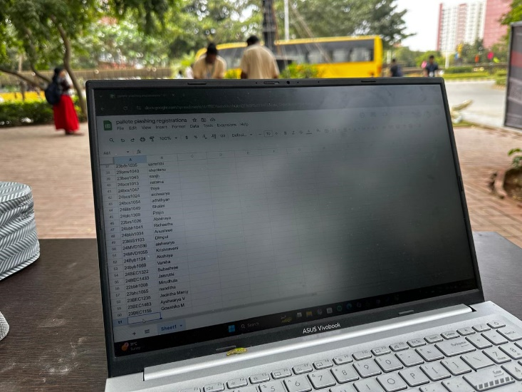8. Volunteered for palette plashing held on 25th February 2025 . worked in registration desk and made sure that the palette is looking good.

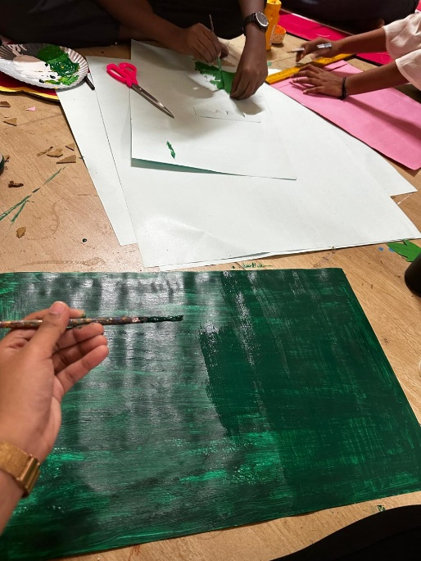9. Volunteered for VIBRANCE AMBIENCE works .

10. participated in ART FOR AZADI event .

11. Participated in Brush and Blush event .